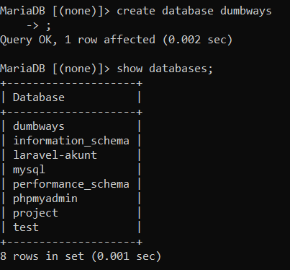

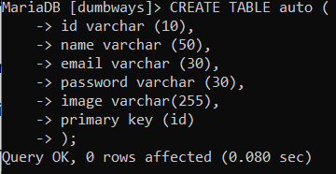

CREATE TABLE auto (

id varchar (10),

name varchar (50),

email varchar (30),

password varchar (30),

image varchar(255),

primary key (id)

);

insert into auto values (“1”, “Yudha”, “dyanpermana106@gmail.com”, “123456”,”image”);

select * from auto;

insert into auto values (“2”, “Permana”, “dyan.permana@widyatama.ac.id”, “123456”,”image”);

select * from auto;

CREATE TABLE article (

id varchar (10),

title varchar (30),

content varchar (255),

image varchar (255),

created_at datetime,

id_user varchar(10),

id_category varchar(10),

primary key (id)

);

CREATE TABLE category(

id varchar (10),

name varchar (50),

primary key (id)

);

insert into category values (“1”, “Article”);

select * from category;

insert into article values (“1”, “Belajar Laravel”, “Laravel Backend”, “image”, NOW(),”1”, “1”);

select * from article

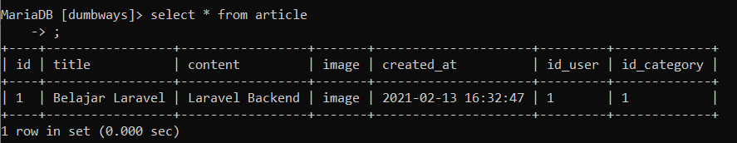

Update article set content =”Laravel Backend part 1” where id=”1”;

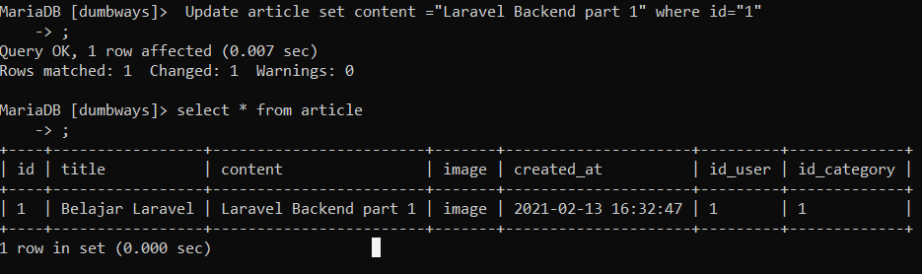

insert into article values (“3”, “Belajar Android”, “Android Basic part 1”, “image”, NOW(),”2”, “1”);

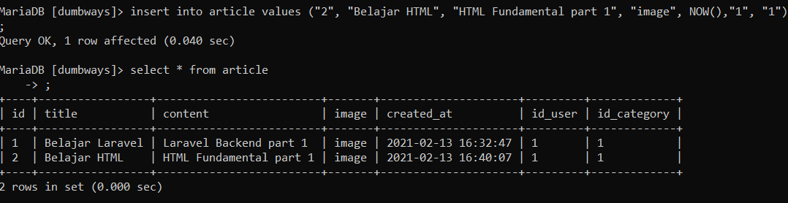

Select * from article where id_user = “2”;

